

Phase 1 Project: Cryptography
Suhaila Alfalasi
Fatima Rabiu
Rania Kanaan
RIT Dubai
Dr. Wesam Almobaidenn
October 4, 2024

Introduction 3
Objectives: 4
Pseudo Code: 5
Description of Algorithm: 10
Implementation Specifications: 13
Appendix: 15
Summary: 20
References 21

Introduction
Cryptography is a mathematical and creative field that depends on receiving information, sentences or data that can be read by all people, then this data is encrypted and made difficult to read and decipher except by the competent authorities who have knowledge about how to decrypt. [1] Encryption is considered one of the most important techniques for protecting information from hacking because it contains system security and secret sub-storage, so encryption ensures the confidentiality of information and prevents tampering with it and forgery, as well as, Encryption and decryption algorithm's security depends on the algorithm. [2]
Furthermore, Ciphers make text communication a mystery to anyone who might try to hack or intercept it. It is also said that Julius Caesar used these ciphers to be able to communicate with his army during war. He is considered one of the first people to use ciphers to protect messages. Through the cipher he used, he decided to move each letter three places below the alphabetical letters in the message so that this would be his standard algorithm (The Caesar Cipher). [3]

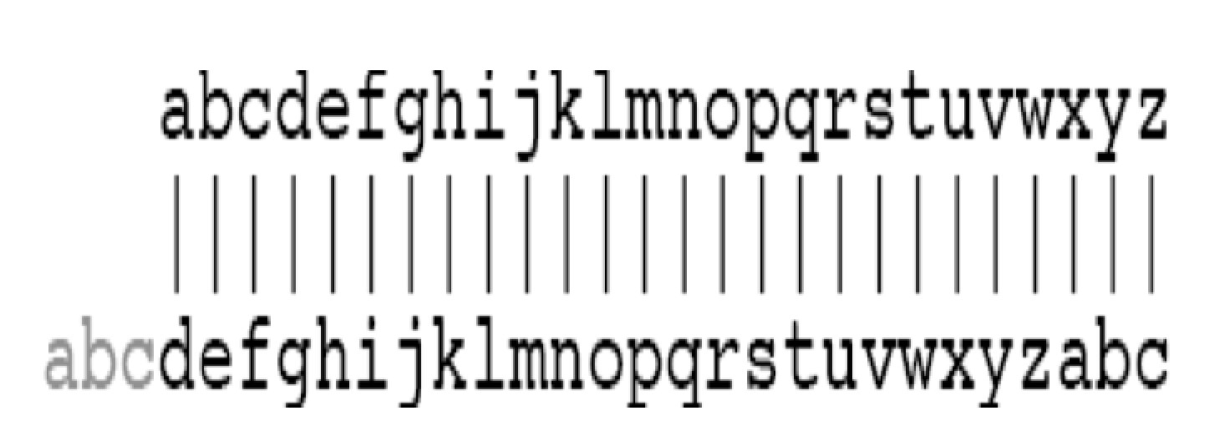
Fig 1: Cesar Cipher working [3]

Objectives:
The aim of this project is for students to understand how encryption algorithms work, through an interface that details the steps required to implement such algorithms. The project also teaches the importance of the process of encryption and decryption for hiding data using mono-alphabetic and Caesar ciphers, making it harder for attackers to crack the code. By the end of this project, a decryption algorithm will be created that matches a specific encryption method, with a focus on classical ciphers, such as monoalphabetic ciphers and Caesar ciphers.

.

Pseudo Code:
DEFINE substitutionTable as 26 characters = { 'h', 'i', 'l', 'w', 'm', 'k', 'b', 'd', 'p', 'c', 'v', 'a', 'z', 'u', 's', 'j', 'g', 'r', 'y', 'n', 'q', 'x', 'o', 'f', 't', 'e' }

FUNCTION findIndex(character)
IF the character is not alphabetic, return -1
END IF
RETURN the Converted character to lowercase and find its index in the alphabet
END FUNCTION

FUNCTION caesarShift(letter, shift)
IF it's not a letter, return the inputted letter
END IF
SET the base to check if it's lowercase or uppercase
RETURN the Shift of the letter by 'shift' positions in the alphabet
END FUNCTION

FUNCTION caesarUnshift(letter, shift)
IF it's not a letter, return the inputted letter
END IF
Set the base to check if it's lowercase or uppercase
RETURN the Reversed Caesar shift by subtracting the shift value
END FUNCTION

FUNCTION encrypt(plainText, cipherText, logFile)
Get the length of the plain text
SET the last substitution index to zero
SET the letter_count to zero
FOR each character in the plain text
IF character is alphabetic THEN
IF it’s 6th alphabetic character substitute the character
SET index equal to the character in the substitution table
IF the index is valid
Substitute the character
Update the last substitution index
Display the substitution
ELSE
keep the character unchanged
END IF
ELSE
Use the last substitution index as the shift value
Perform the Caesar shift
Print the shift
END IF
Increment the alphabetic character count
ELSE
Non-alphabetic characters will stay as it is
END IF
WRITE each encryption step to the log
END FOR
TERMINATE the cipher text
END FUNCTION

FUNCTION decrypt(cipherText, plainText, logFile)
GET the length of the plain text
SET the last substitution index to zero
SET the letter_count to zero
FOR each character in the ciphertext
IF the current character is alphabetic
IF its 6th alphabetic character reverse every 6th position of the substitution
FOR each letter in substitutionTable
IF the character is found
Place its original letter
Update the last substitution index
Display the original characters
BREAK
END IF
END FOR
ELSE
SET the last substituted index as the shift value
Perform the Caesar unshift
Display the shifting of the original
END IF
INCREMENT the alphabetic character count
ELSE
Non-alphabetic characters stays as it is
END IF
WRITE each decryption step and store in the logfile
END FOR
TERMINATE the plainText
END FUNCTION

MAIN Function
Pointer the Files for text files
IMPLEMENT Buffers for plain, cipher, and decrypted text
OPEN "plaintext.txt" and read into plain text
IF the file can't be opened
DISPLAY an error message
EXIT
Read file into the plainText buffer
CLOSE the plain text file
OPEN "ciphertext.txt" for writing
OPEN "log.txt" for logging
IF either file can't be opened
DISPLAY an error message
EXIT
CALL encrypt(plainText, cipherText, logFile)
WRITE cipherText to "ciphertext.txt"
CLOSE cipher text
OPEN "decrypted.txt" for writing
IF the file can't be opened
DISPLAY an error message
EXIT
CALL decrypt(cipherText, plainText, logFile)
WRITE plainText to "decrypted.txt"
CLOSE the decrypted file
PRINT "Encryption and decryption completed"
END MAIN

Description of Algorithm:
This code compromises both encryption and decryption algorithms.. The encryption algorithm makes use of the plain text file in saved (.txt) that contains the phrase ‘if we had anything confidential to say’ in the same folder as the c code and uses it to change it into cipher text with the help of the substitution and caesar cipher techniques.
Encryption
Substitution Cipher:
In the substitution cipher uses the sixth letter of the alphabet and replaces it with the corresponding letter from the given table.To explain further, if are going to encrypt ‘if we had anything’ , we will count ‘i’ as the first letter then count down to ‘a’ as the 6th letter.The ‘a’ in ‘anything’ in the table is replaced by ‘h’ , the rest remain the same till the next 6th letter. while the next letter is ‘n’ in ‘confidential’ , which is replaced by ‘u’ and so it goes.
Spaces are not changed in this process.

Caesar cipher method:
This happens after substitution. The Caesar cipher method shifts the other letters left based on their numbered position,this is done to the next 5 letters after each substitution. For example, with the first substitution example given above being ‘a’ to ‘h’, it gives the caesar shift 0 , as the letter ‘a’ is 0 in the alphabets, which will also be the next shift number (0) for the next five letters.as a result, ‘n’ , ‘y’, ‘t’, ‘h’, ‘i’ all stay the same. However if we do the substitution ‘n’ turns into ‘u’ as ‘n’ is the 13th letter so shift= 13, where by ‘f’ turns into ‘s’, ‘i’ turns into ‘v’ and so on for the rest of the next 3 letters.
Spaces are not changed in this process.
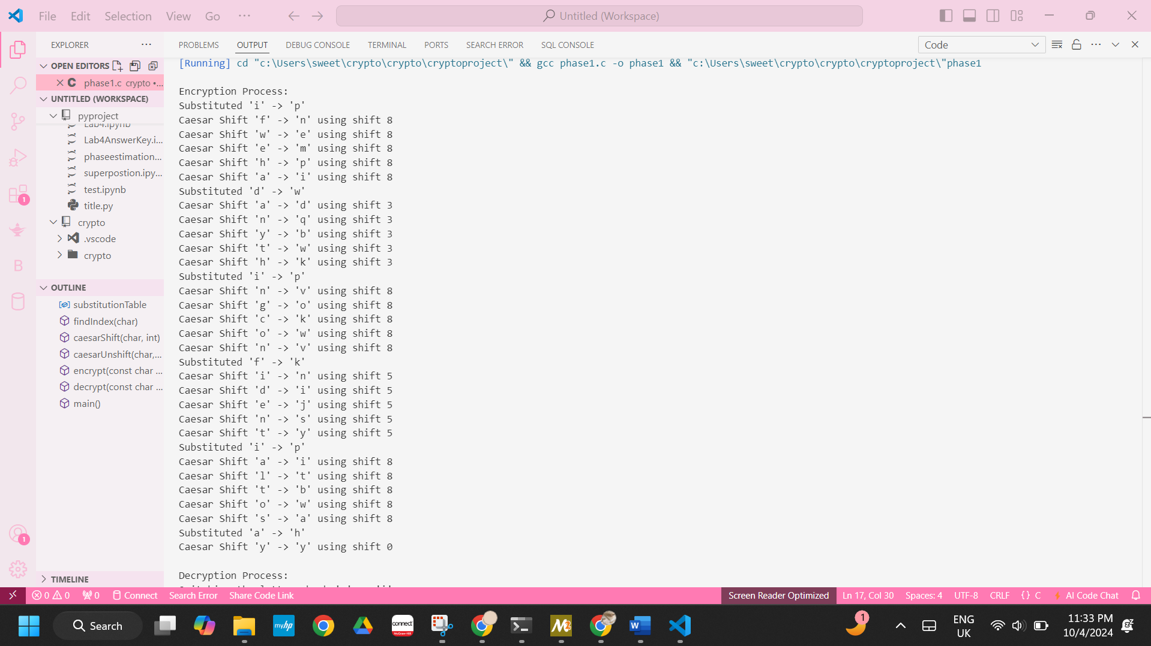
Decryption:
The decryption process does the exact opposite of the encryption. For example in decryption when it comes to substituting the sixth letter ‘h’ in the cipher text that we knew previously as ‘a’ , the same way we reserve the other substitutions in order of their positions in the ciphertext. For the Caesar shift, we unshift it, in other words after every substitution, the next 5 use the same shift number previously in the encryption to move back.

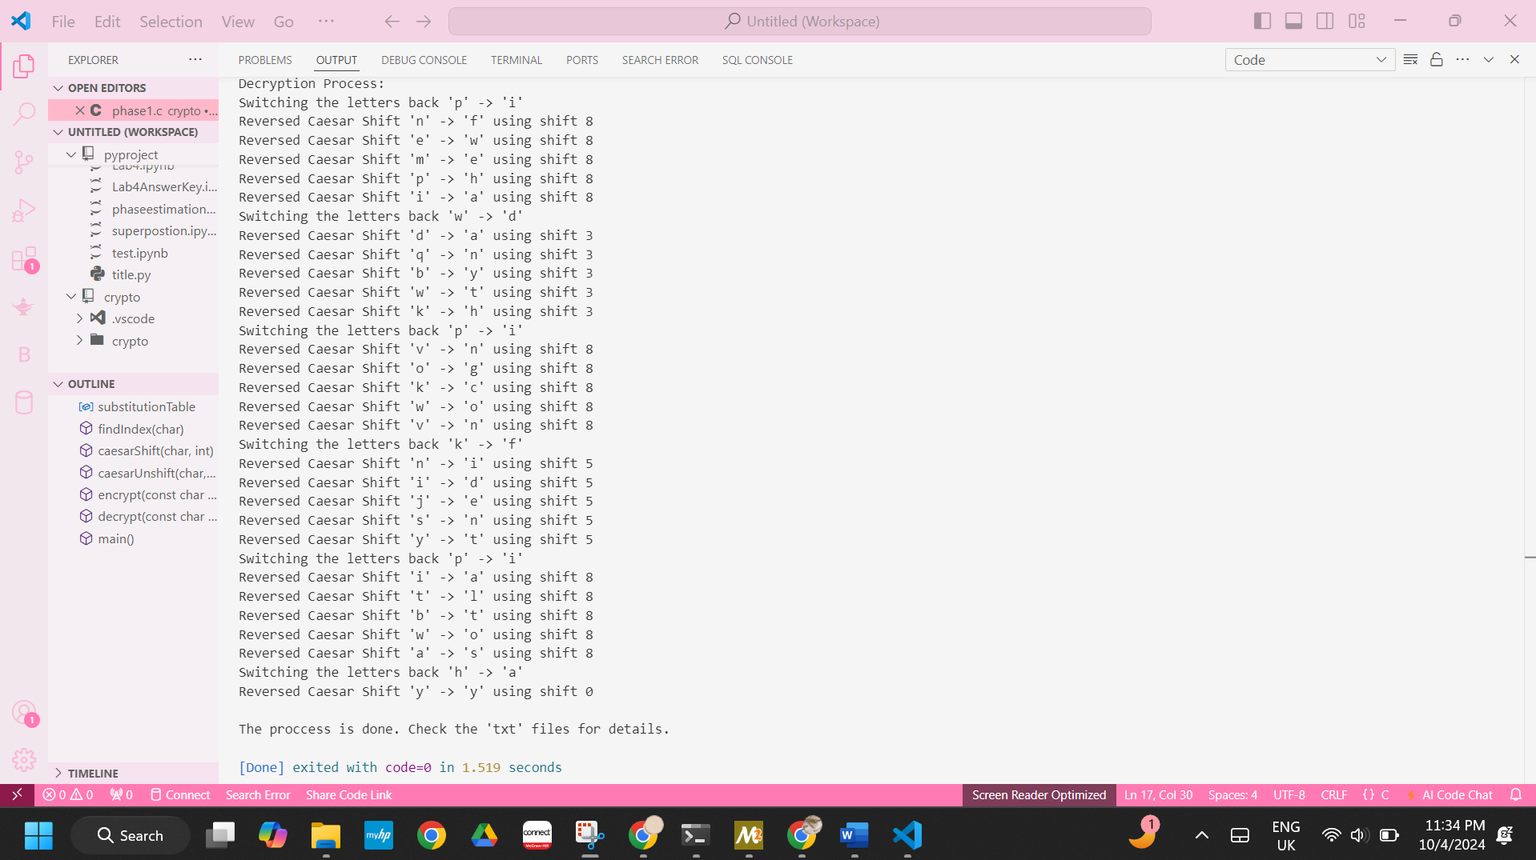

Implementation Specifications:
- Language and Libraries used:
- The programming language used in this project is C language.
- The libraries used are stdio.h, stdlib.h, string.h, and ctype.h.
  - The stdio.h is used for printing the outputs in the terminal and file handling such as opening and closing the files
  - The stdlib.h is a library used for error handling such as ‘perror’
  - The string.h is used for the characters operations such as ‘strlen’
  - The ctype.h is used for character handling such as the ‘islower’
- The Substitution Table:
- The mono-alphabetic substitution table is 26 letters not placed in the right alphabetical order and it is not repeated, which will be placed for every 6 characters in the sentence. The substitution will be based on the alphabetical order corresponding to the mapped substitution table.
- The Cipher Technique Used:
- Mono-alphabetic substitution table: Is mapping to the letter from the alphabetical order to its corresponding substitution table.
- Caesar Cipher: is shifting based on the previous letter that has been mapped using the mono-aplabetical substitution.
- Reversing the Caesar Cipher: is when do the decryption process of reversing the caesar cipher substitution of the previous letter back to its original letter.
- Encryption Process:
- Is the entered characters in the file called ‘Plain text’ that will loop to each character in that plaintext and substituted based on the previous character position into a file called the ‘Cipher text’
- Decryption Process:
- Is the process of looping in the file ‘Cipher text’ that will substitute the character back to its original character into the file of the ‘decryption file’ .

6. File I/O part:
- First Input Files:
plaintext.txt: which contains the plain text to be encrypted.

- Second Output Files:
ciphertext.txt: Stores the result of the text that has been encrypted.
decrypted.txt: Stores the text that has been decrypted after finishing the cipher text.
log.txt: Logs the encryption and decryption steps for verification Each transformation from plain text to cipher text, and cipher text to plain text is recorded.

7. Error Handling:
- The program prints an error message after checking if input/output files are successfully opened.

8. Program Flow:
- The main function holds the entire process:
it reads from a file the plain text. then it calls the encryption function to encrypt the text then writes the result to the cipher text file. after that, it calls the decryption function to decrypt the text and check if it matches the original. All these steps are logged in log.txt for transparency and debugging.

9. Constraints:
- The program handles for the plain text and encrypted text up to 256 characters. The only characters that are encrypted are the alphabetic ones; non-alphabetic characters remain unchanged.

Appendix:
#include <stdio.h>
#include <stdlib.h>
#include <string.h>
#include <ctype.h>
// Substitution table This array represents a substitution cipher key. Each letter of the alphabet is mapped to another character in this table.
char substitutionTable[26] = {
'h', 'i', 'l', 'w', 'm', 'k', 'b', 'd',
'p', 'c', 'v', 'a', 'z', 'u', 's', 'j',
'g', 'r', 'y', 'n', 'q', 'x', 'o', 'f',
't', 'e'
};
// This function takes a character as input and returns its position in the alphabet, making it easier to shift.
int findIndex(char ch) {
if (!isalpha(ch)) return -1; // Return -1 for non-alphabetic characters
return tolower(ch) - 'a';
}
// This function shifts a letter by a certain number in the alphabet
char caesarShift(char letter, int shift) {
if (!isalpha(letter)) return letter; // If not a letter, return unchanged
char base = islower(letter) ? 'a' : 'A';
return (letter - base + shift) % 26 + base;
}
// This function undoes the Caesar shift, reversing the encryption by shifting the letter backward.
char caesarUnshift(char letter, int shift) {
if (!isalpha(letter)) return letter; // If not a letter, return unchanged
char base = islower(letter) ? 'a' : 'A';
return (letter - base - shift + 26) % 26 + base;
}
// This function encrypts the plain text by substitution and Caesar shifts
void encrypt(const char *plainText, char *cipherText, FILE *outputFile) {
int len = strlen(plainText);
int lastSubstitutionIndex = 0; // Store the last substitution index
int letter_count = 0; // To count alphabetic characters
//Every 6th alphabetic character is substituted using the substitution table, and the next 5 alphabetic characters are shifted using Caesar cipher based on the last substitution index.
for (int i = 0; i < len; i++) {
if (isalpha(plainText[i])) {
if (letter_count % 6 == 0) {
int index = findIndex(plainText[i]);
if (index >= 0 && index < 26) {
cipherText[i] = substitutionTable[index];
lastSubstitutionIndex = index;
printf("Substituted '%c' -> '%c'\n", plainText[i], cipherText[i]);
} else {
cipherText[i] = plainText[i];
}
} else {
int shift = lastSubstitutionIndex;
cipherText[i] = caesarShift(plainText[i], shift);
printf("Caesar Shift '%c' -> '%c' using shift %d\n", plainText[i], cipherText[i], shift);
}
letter_count++;
} else {
// Non-alphabetic characters are left unchanged
cipherText[i] = plainText[i];
}
// Output each step to the log file
fprintf(outputFile, "Encrypting: '%c' -> '%c'\n", plainText[i], cipherText[i]);
}
cipherText[len] = '\0'; // Null-terminate the cipher text
}
// This function reverses the encryption process.
void decrypt(const char *cipherText, char *plainText, FILE *outputFile) {
int len = strlen(cipherText);
int lastSubstitutionIndex = 0; // Store the last substitution index
int letter_count = 0; // To count alphabetic characters
//Every 6th character is decrypted by reversing the substitution, and the next 5 characters are decrypted by reversing the Caesar shift.
for (int i = 0; i < len; i++) {
if (isalpha(cipherText[i])) {
if (letter_count % 6 == 0) {
for (int j = 0; j < 26; j++) {
if (substitutionTable[j] == cipherText[i]) {
plainText[i] = 'a' + j;
lastSubstitutionIndex = j;
printf("Switching the letters back '%c' -> '%c'\n", cipherText[i], plainText[i]);
break;
}
}
} else {
int shift = lastSubstitutionIndex;
plainText[i] = caesarUnshift(cipherText[i], shift);
printf("Reversed Caesar Shift '%c' -> '%c' using shift %d\n", cipherText[i], plainText[i], shift);
}
letter_count++;
} else {
// Non-alphabetic characters remain unchanged
plainText[i] = cipherText[i];
}
// Output each step to the log file
fprintf(outputFile, "Decrypting: '%c' -> '%c'\n", cipherText[i], plainText[i]);
}
plainText[len] = '\0'; // Null-terminate the plain text
}
// This is the main part of the program that handles file operations.
int main() {
FILE *plainTextFile, *cipherTextFile, *decryptedTextFile, *logFile;
char plainText[256], cipherText[256], decryptedText[256];
// It opens a plain text file, reads its content, and encrypts it.
plainTextFile = fopen("plaintext.txt", "r");
if (!plainTextFile) {
perror("Error opening plain text file");
return 1;
}
// Read the plain text from the file
fgets(plainText, sizeof(plainText), plainTextFile);
fclose(plainTextFile);
// The cipher text is written to ciphertext.txt, and the decryption process is validated by decrypting it back and saving the result in decrypted.txt.
cipherTextFile = fopen("ciphertext.txt", "w");
logFile = fopen("log.txt", "w");
if (!cipherTextFile || !logFile) {
perror("Error opening output files");
return 1;
}
// Encrypt the plain text and show steps in terminal
printf("\nEncryption Process:\n");
encrypt(plainText, cipherText, logFile);
fprintf(cipherTextFile, "%s", cipherText);
fclose(cipherTextFile);
decryptedTextFile = fopen("decrypted.txt", "w");
if (!decryptedTextFile) {
perror("Error opening decrypted text file");
return 1;
}
printf("\nDecryption Process:\n");
decrypt(cipherText, decryptedText, logFile);
fprintf(decryptedTextFile, "%s", decryptedText);
fclose(decryptedTextFile);
fclose(logFile);
printf("\nThe proccess is done. Check the 'txt' files for details.\n");
return 0;
}

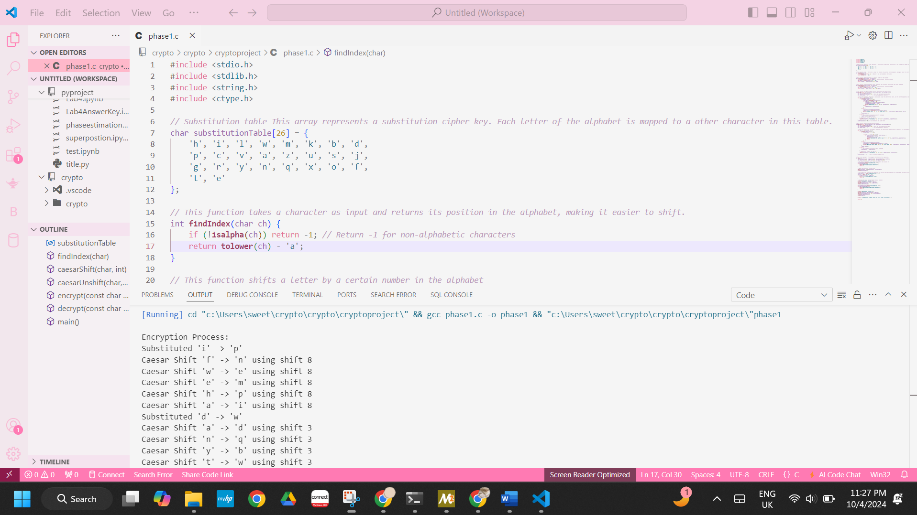
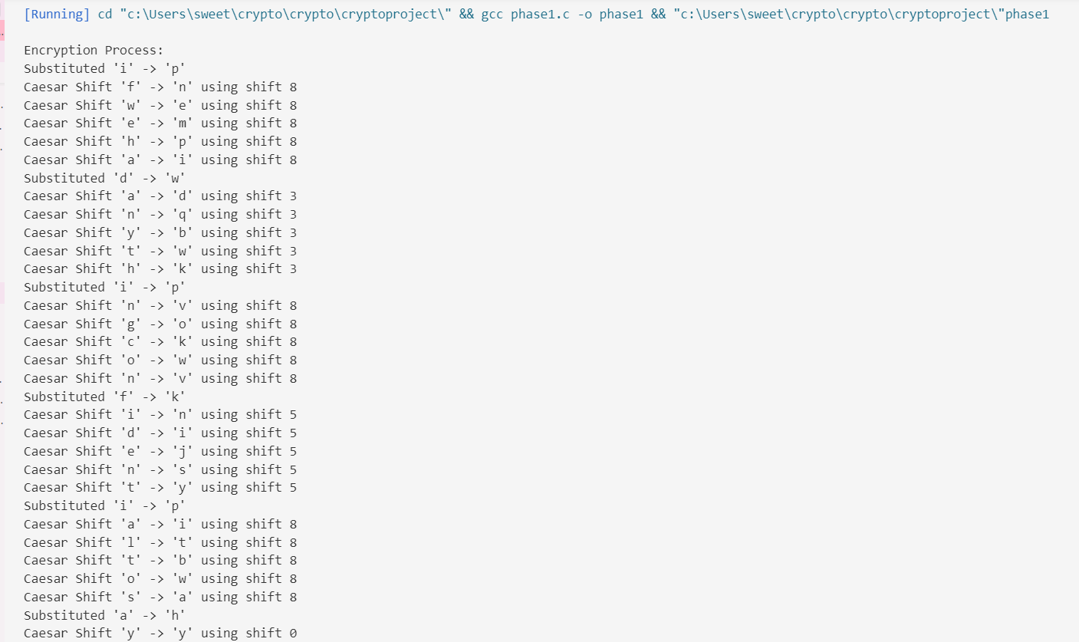
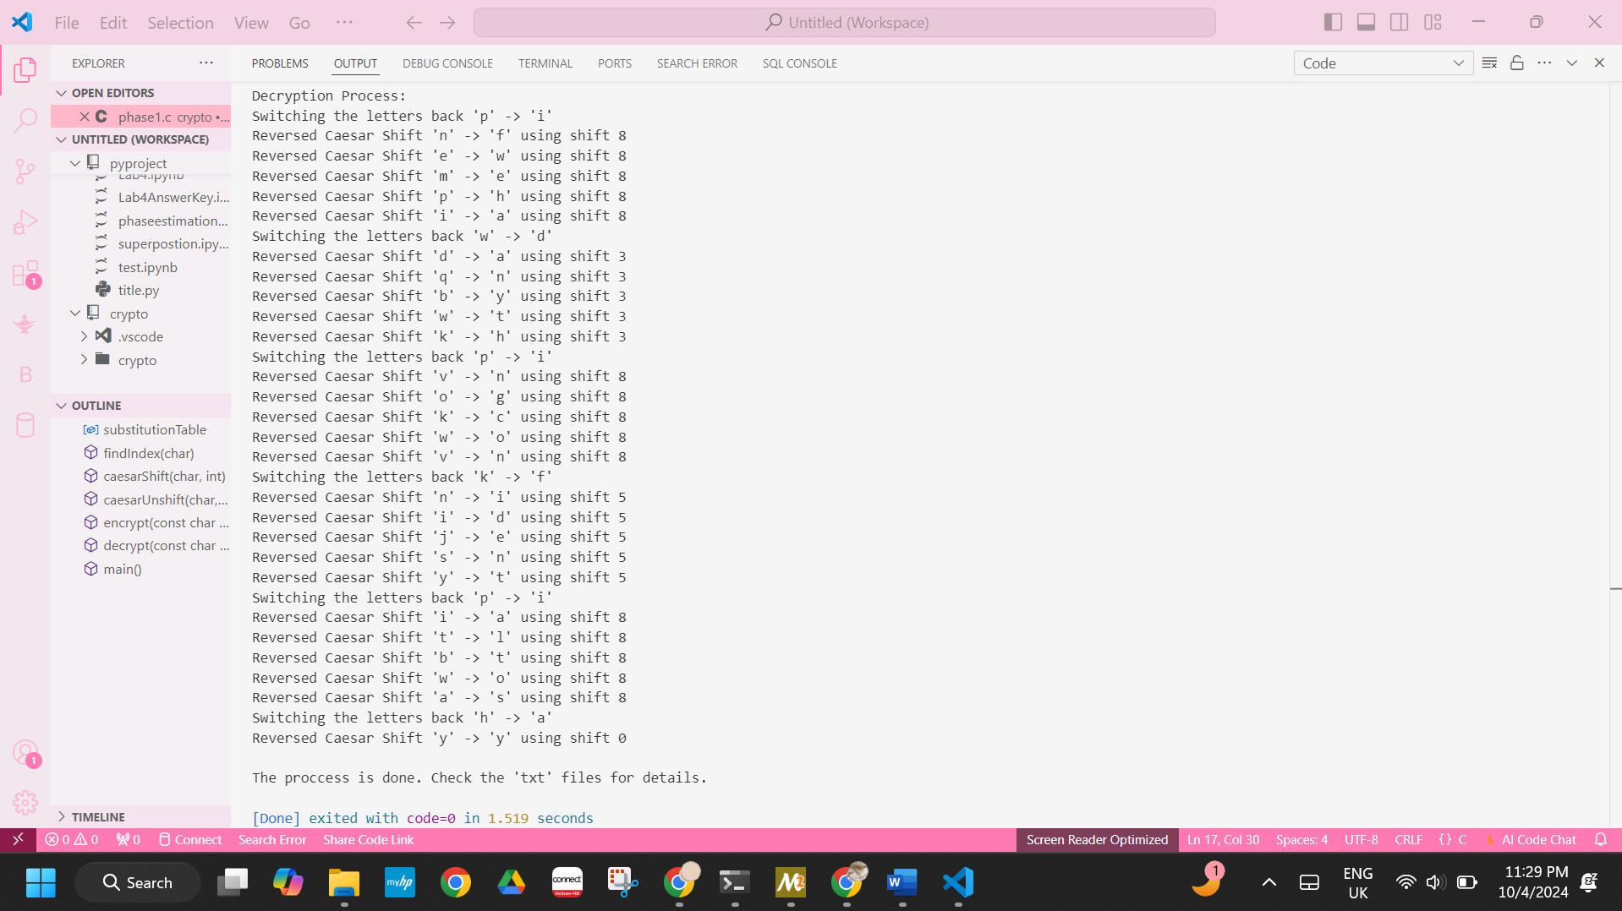

Summary:
This project provides for a hybrid encryption and decryption using a combination of substitution cipher and Caesar cipher. Through a predefined substitution table, every sixth letter of the alphabet is replaced with a plain letter from this specified substitution table. While the remaining letters undergo a Caesar transformation based on the position of the last letter replaced, each transformation step can be recorded by the ciphertext system, and the ciphertext can then be decrypted back to its original form. Files are then used to store the plaintext and ciphertext to record the entire process.

References
[1] | R. Lele, R. Jainani, V. Mikhelkar, A. Nade, and V. Meshram, “The book cipher optimised method to implement encryption and decryption,” International Journal of Scientific & Technology Research, vol. 3, pp. 11–14, 2014.

[2] | X. Zhou and X. Tang, “Research and implementation of RSA algorithm for encryption and decryption,” in Proceedings of 2011 6th International Forum on Strategic Technology, 2011, vol. 2, pp. 1118–1121.

[3] | K. Goyal and S. Kinger, “Modified Caesar cipher for better security enhancement,” International Journal of Computer Applications, vol. 73, pp. 26–31, 2013.

